Payroll Application

## Instructions

Instructions for “Payroll Application”

**Please read and follow all the instructions for a proper use of the application!**

## Pre-requisites:

1. **Trial Balance Template** – should be made on the template presented down below:



In the **TB Template**, map the information from the Trial Balance provided by the client onto the header from the excel above. (Account, Description, Opening Balance (OB), Debit Movement (DM), Credit Movement (CM), Closing Balance (CB), RDC & RCC). In the RDC and RCC fields, please fill the monthly debit (RDC) and monthly credit (RCC) amounts from the trial balance for December/last month of the financial year.

1. **D112** –An XML file needs to be downloaded from the D112.pdf, as shown below:

After opening the PDF document, click on the clip on the left side (Attachments):

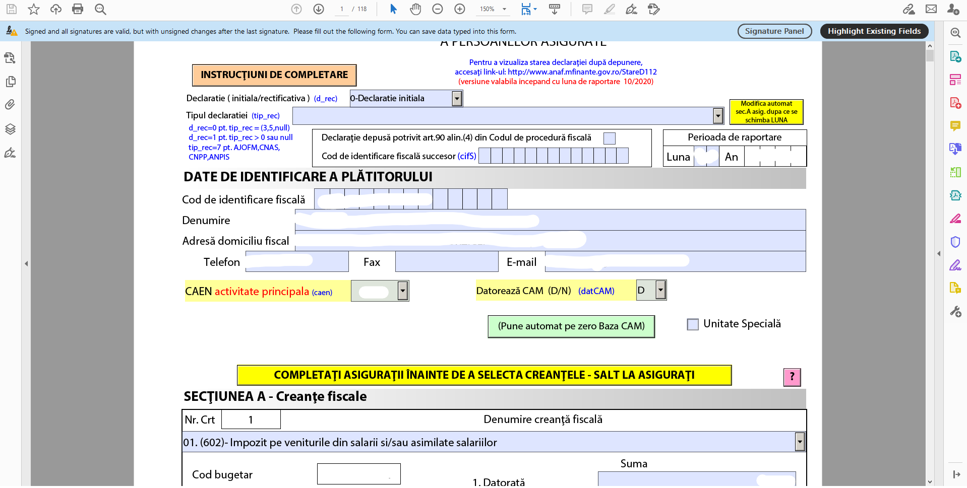

Next, right-click on the XML document and save it (Save Attachment) in your desired location:

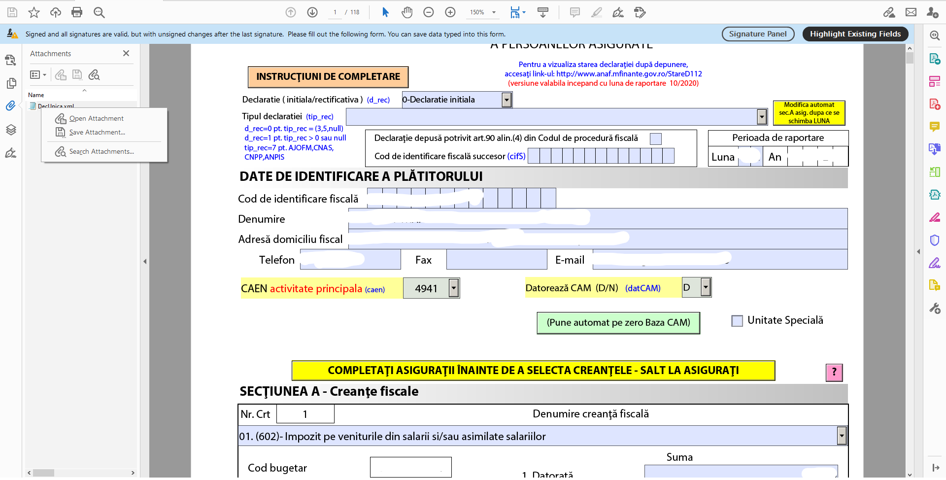

1. **PBC Template** - should not be modified by the user. The template can be found down below:



1. **Monthly P&L** - should not be modified by the user (not even the sheet names). It can be found down below:



**Good to know:** even if you don’t have the information for all months, it is mandatory that you maintain the same header. So, for example, if you have the information from January to September (ex: at interim), you must also write the rest of the months in the header, even if the columns will be empty.

## Instructions:

1. After connecting to the platform, go to **Payroll**:

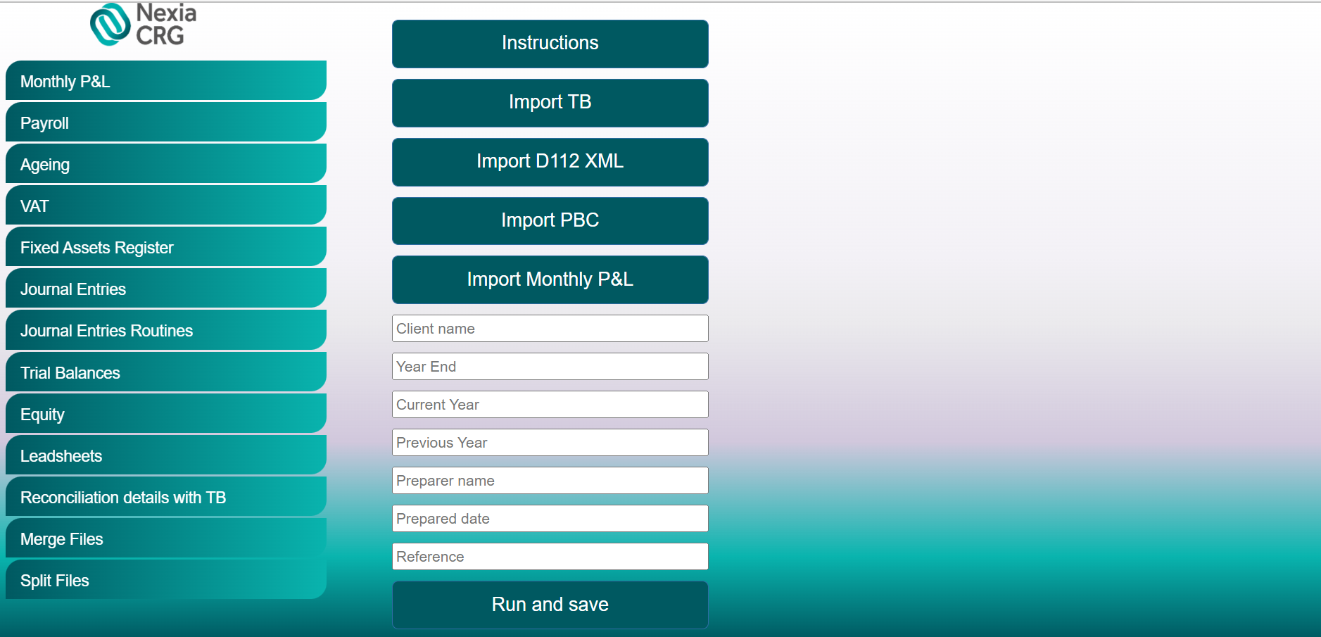

1. Enter the Client’s name, the period end (MM/DD/YYYY) of the audit (Year End), the current and previous year (ex. 2021,2020 etc.), the Preparer’s name, Prepared date and Reference.
2. Click “Import TB” and import the Trial Balance template.
3. Click “Import D112 XML” and import the XML file.
4. Click “Import PBC” and import the PBC Template.
5. Click “Import Monthly P&L” and import the Monthly P&L Template, containing both current year and previous year.
6. Click “Run and save”. Once clicking that, the robot will process your request and download the file in your designated downloads folder.
7. Finally, you should obtain an Excel document named “V10 Payroll Analysis” + the name of the client.

If you encounter any issues or if you have any other questions or suggestions, please contact:

Cristian Iordache, [cristian.iordache@ro.gt.com](mailto:cristian.iordache@ro.gt.com)

Bogdan Constantinescu, bogdanconstantinescu@ro.gt.com